TEAL – Apply for Access TSDS Portal Parallel

Each district/charter parallel school will be required to have at least one person with TSDS Portal Parallel access.

- Log into TEAL.
- Click on My Application Accounts.
- Click on Request New Account.

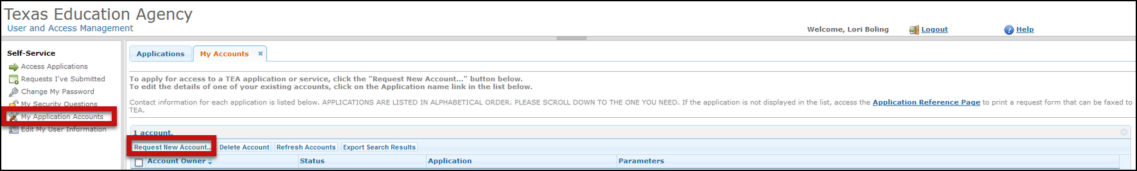

- On the Request New Account, scroll down and click on the TSDSPortalParallel to add the application to your TEAL account.

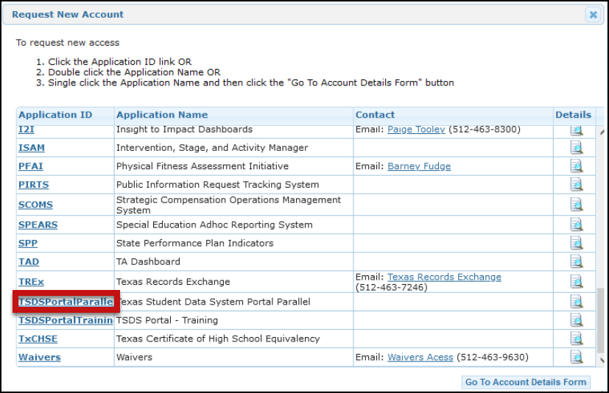

- On the My Accounts screen, under the Texas Student Data System Portal Parallel application, select Add Access.

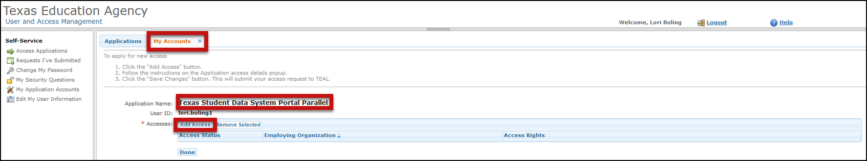

- In the Employing Organization and Requested Organization ID, enter your district/charter county district number.

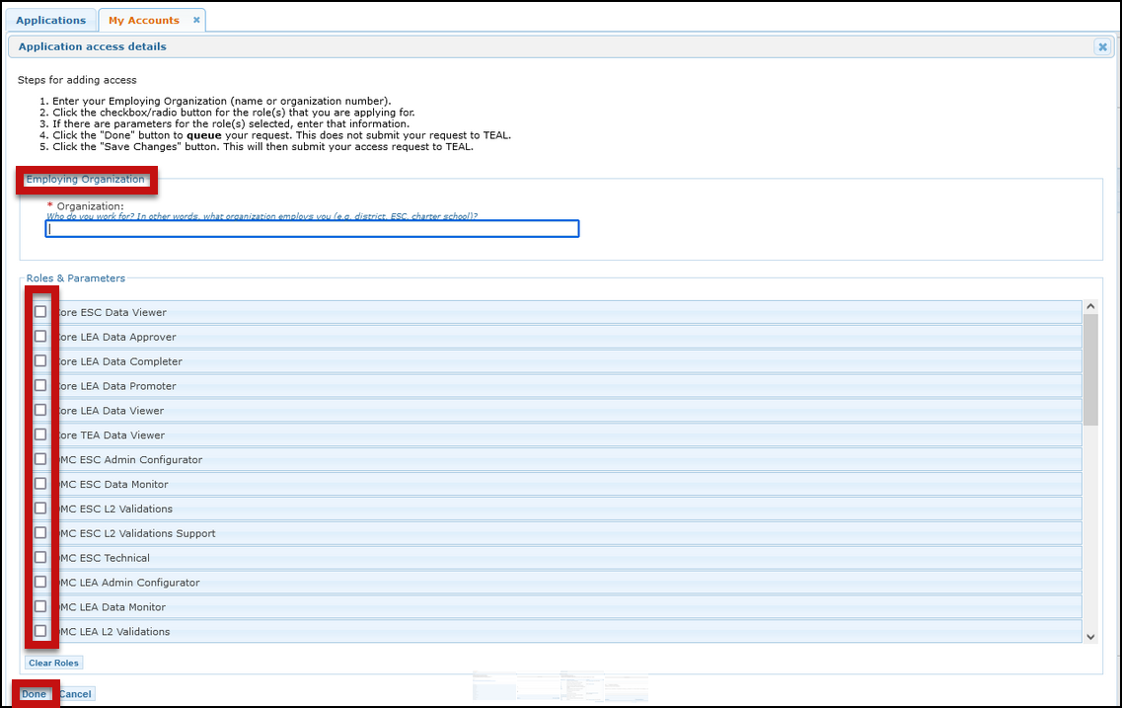

- Select the appropriate Roles and Parameters based on your responsibilities for the parallel year.

- Core LEA Data Completer (Promote, Validate, View Reports, Complete Collections – select all that apply to your district)
- DMC LEA Data Monitor (DMC L1.5 Filters, DMC Map Descriptors, DMC Search Data)
- DMC LEA L2 Validations (L2 Validations for Core Collections and PEIMS Submissions – select all that apply to your district)
- DMC LEA Technical (DMC Manage Key and Secret – preferably only 1 or 2 staff members should have this access)
- PEIMS Data Completer (Promote, Validate, View Reports, Complete Submissions – select all except Download Validation Tool)

- Click Done.
- Click *Save Changes*. It is important that you click Save Changes before you exit the screen.

